Programing Assignment 3

Name: Chhay Lay Heng

Class: CS3345.004

1. Screenshot

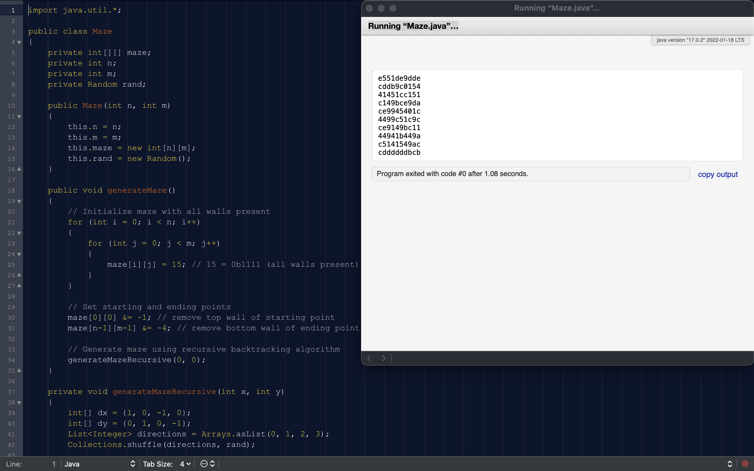

1. Extra
   1. Create a starting node with distance 0 and add to queue.
   2. If the priority queue is not empty
      * Pop the node with the shortest distance from the queue
      * For the neighbor queue, calculate the distance to the node with the penalty of knocking down the wall. If the node has shorter than the current distance, update its distance to the queue.
      * If the update distance is shorter, mark the wall between the current node and the neighbor node as knocked down.
      * Add neighbor node to the queue.
   3. Once it reaches the destination, we can track the path with the minimum total penalty.

The run time for the algorithm is O((m+n)logn).